**Name: _______________________________________**

**Python Activity 4: Formatting Output**

|  |
| --- |
| **Learning Objectives**  Students will be able to:  *Content:*   * Incorporate numeric formatting into print statements   *Process:*   * Create *Python* code that formats numeric output   **Prior Knowledge**   * Material covered in Activity 3 |

**Critical Thinking Questions:**

1. So far you have not been concerned about formatting output on the screen. Now you will discover how Python allows a programmer to precisely format output. Some of the differences are very subtle, so take notice of the differences in outputs.

Start by entering and executing the following code.

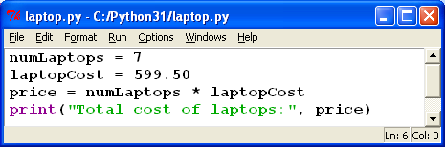

a. What is the problem with the manner in which the output is displayed?

Total cost of laptops: 4196.5

b. Replace the last line of code with the following:

**print("Total cost of laptops:",** **format(price,'.2f'))**

How did the output change?

Total cost of laptops: 4196.50

c. Replace the last line of code with the following:

**print("Total cost of laptops: $", format(price,'.2f'))**

Discuss the change in the output.

This time you get dollar sign before the price.

d. Experiment with the number “.2” in the print statement by substituting the following numbers and state the results.

.4 $ 4196.5000 .0 $ 4196

.1 $ 4196.5 .8 $ 4196.50000000

e. Now substitute ‘.2’ with the following numbers in the same print statement. These numbers

contain a whole number and a decimal. State the output for each number.

2.5 $ 4196.50000 12.2 $ 4196.50 3.1 $ 4196.5

f. Explain what each part of the format function: **format(variable, “n.nf”)** does in a print statement where n.n represents a number.

variable The number you want to be formatted. First n Minimum Number of characters before the decimal

Second n amount of Decimal places f Format

g. Revise the print statement by changing the “f” to “d” and *laptopCost = 600*. Execute the statements and explain the output format.

**print("Total cost of laptops:", format(price,'2d'))**

**print("Total cost of laptops:", format(price,'10d'))**

Total cost of laptops: $ 4200

Total cost of laptops: $ 4200

h. Explain how the function **format(var,'10d')** formats numeric data. **var** represents a whole number.

______________________________________________________________________________

|  |
| --- |
| **FYI:** Computers perform four main operations on data:   * **Input** data into a computer * **Output** data to a screen or file * **Process** data using arithmetic, logical, searching or sorting operations * **Store** data |

2. Use the following program to answer the questions below.

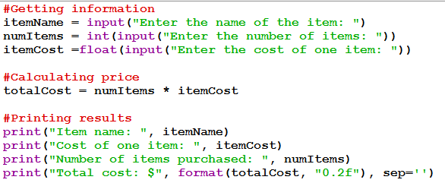

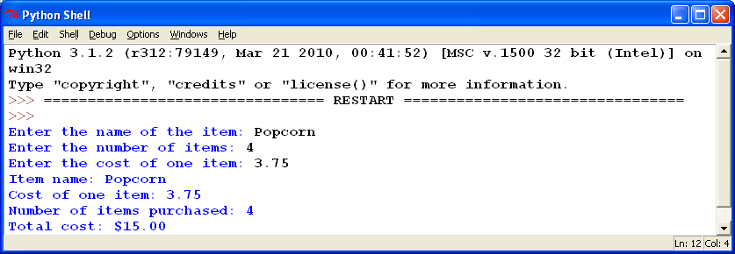

a. In the program listed above, label the code that executes any of the four main operations: *Input, Output, Processing, Storage*

b. Examine the last line of code and its corresponding output. Explain what **sep= ‘ ‘** does.

It makes it so that there is no separation between the dollar6 sign and the value.

3. Enter and execute the following code: **print(“Hello” * 10).** What does it do?

**Prints HelloHelloHelloHelloHelloHelloHelloHelloHelloHello**

**Application Questions: Use the Python Interpreter to check your work**

1. Write one line of Python code that will print the word “Happy!” one hundred times.

print("Happy!" * 100)

2. Assume: itemCost = input(“Enter cost of item: “)

a. Write one line of code that calculates the cost of 15 items and stores the result in the variable *totalCost*

numItems = int(input("Enter the number of items: "))

b. Write one line of code that prints the total cost with a label, a dollar sign, and exactly two decimal places. Sample output: **Total cost: $22.50**

print("Total costs: $", format(totalCost, "0.2f"), sep='')

3. Assume: height1 = 67850

height2 = 456

Use Python formatting to write two print statements that will produce the following output exactly at it appears below:

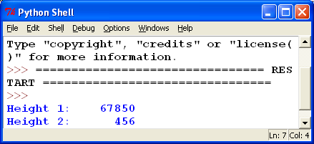

**height1=67850**

**height2=456**

**print("Height 1:", format(height1, "12.0f"))**

**print("Height 2:", format(height2, "12.0f"))**

4. You have already completed the following program in a previous activity. Recode the program so that the output is formatted properly.

Create a program the outputs the total cost of a lunch order. Users should be prompted to input the number of hamburgers, fries, and drinks they want and the program should print the total cost of the order. The price of hamburgers is 2.00, fries is 1.50, and drinks is 1.00. Be creative and professional in prompting the user for the information and in displaying the output.

hamburgers = float(input("How many hamburgers would you like?: "))

fries=float(input("How many orders of fries would you like?: "))

drinks=float(input("How many drinks would you like?: "))

burgerCost=(hamburgers*2.00)

fryCost=(fries*1.50)

drinkCost=(drinks*1.00)

totalCost=(burgerCost+fryCost+drinkCost)

print("Your total will be $", format(totalCost, "0.2f"), sep='')